Statistics: The Science of Decisions Project

Questions For Investigation

1. What is our independent variable? What is our dependent variable?
   1. Independent Variable – the congruency of the color/word
   2. Dependent Variable – the time it takes for people to finish reading the words
2. What is an appropriate set of hypotheses for this task? What kind of statistical test do you expect to perform? Justify your choices.

Note: I found it difficult to display the mathematical symbols within the PDF. Please excuse this. Let “H0” symbolize the null hypothesis, “Ha” be the alternative hypothesis, “μ congruent” be the mean for the congruent condition, “μ incongruent” be the mean for the incongruent condition, “!=” be “not equal to”, and “<=” mean less than or equal to.

* 1. Null – There will be no difference in time to complete the task for the congruent and incongruent conditions. H0: μcongruent = μincongruent
  2. Alternative –
     1. There will be a significant difference, Ha: μ congruent != μ incongruent (non-directional) OR
     2. The time will be greater for the incongruent group than the congruent group (Ha: H0: μ congruent <= μ incongruent). **This is the alternative I will be using.**
     3. Note: Both are reasonable alternative hypotheses depending on your assumptions. If you expect the congruent condition to be easier/faster, then you would be fine with a directional hypothesis. Otherwise, a non-directional hypothesis is fine if you want to be more conservative with your approach.
  3. Statistical test:
     1. I expect to perform a dependent t – test with 24 degrees of freedom, p-value .05, one – tailed due to the within subject design and the fact that I would expect the incongruent design to be more difficult and thus take longer for participants.

1. Report some descriptive statistics regarding this dataset. Include at least one measure of central tendency and at least one measure of variability.
   1. Mean:
      1. Congruent – 14.16
      2. Incongruent – 22.51
      3. Difference – 8.35
   2. Variance: 26.31
   3. SD: 5.13
   4. SEM: 1.03
2. Provide one or two visualizations that show the distribution of the sample data. Write one or two sentences noting what you observe about the plot or plots.

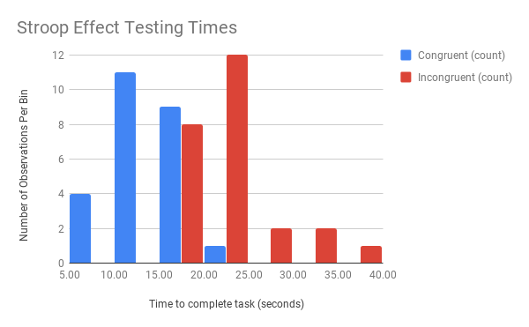

Testing time tends to be shorter for the Congruent condition than for the Incongruent condition. We can also notice that there is no overlap on the outer ends of the distributions.

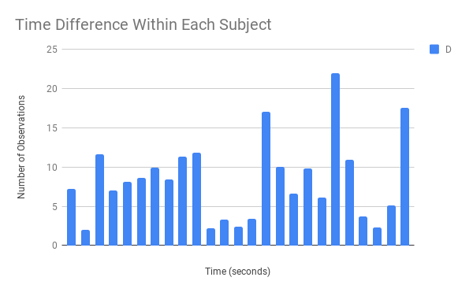

Within each subject, the difference between the two conditions is always positive, with the Incongruent condition always having a slower time and thus being greater than the time for the Congruent condition.

1. Now, perform the statistical test and report your results. What is your confidence level and your critical statistic value? Do you reject the null hypothesis or fail to reject it? Come to a conclusion in terms of the experiment task. Did the results match up with your expectations?
   1. T(df = 24) = 8.14, p< .05 , one-tailed positive, dependent
   2. Tcritical = 1.711, Confidence level 95%
   3. We reject the null as Tcalculated > Tcritical. The results match up with our expectations that subjects would take longer on average in the Incongruent condition than the Congruent condition.
2. Optional: What do you think is responsible for the effects observed? Can you think of an alternative or similar task that would result in a similar effect? Some research about the problem will be helpful for thinking about these two questions!
   1. I think that the Incongruent condition causes more difficulty for readers as they need to tease apart the information given to them in order to react accordingly. They need to remove the false information they receive (the word being a color that is not the answer) before being able to discern the color of the text. Since our default when seeing words is to read them, this proves difficult when the text is a color that is intended to throw you off. On top of this, in the Congruent condition, readers can just read the text and/or observe the color of the text. Both sources of information help you in the Congruent condition.
   2. I imagine there would be a similar effect if you were shown pictures of animals where the text was the name of a different animal and you were instructed to choose between two answers as quickly as possible. One being the sound of the animal on the picture shown, the other being the sound of the animal in text. The correct answer would be the animal in text. The two conditions in this case could also be congruent or incongruent.

Resources:

<https://www.graphpad.com/quickcalcs/>

No resources besides the Udacity course and the Graphpad calculator were used. I was already familiar with the Stroop Effect.